Instructions for Abstract Preparation for T&T IAC 2024

Author ONE¹, Author TWO² and Author THREE^{3*}

¹Department of Chemical Engineering, University, City, Country
²Department of Chemical Physics, University, City, Country
³Department of Physical Chemistry, University, City, Country
*Corresponding author: T&T IAC@ntu.edu.tw

Keywords: Keywords1, Keywords2, Keywords3

Introduction
The abstract should be in double column format and no more than 500 words (excluding acknowledgements and references). Use A4 page set-up and make all margins (top, bottom, left and right) 20 mm wide. Start the text about 6 cm from the top of the page. Use 10pt Times New Roman font (except for the title which should be in 15pt bold and in title case). Centre the title, the authors’ names, keywords and contact email address. Please compose a title that clearly and succinctly describes the content of your work.
Start each paragraph with an indent. Justify the body of the text both left and right. Do not use page numbers. Keywords are there to draw attention to your abstract, and to help the organizers allocate the presentation to the most appropriate session.
Use clear English to write your abstract, with an emphasis on describing what is new and why it should attract the attention of the audience.
Ensure that Figures and Tables have captions and that they are numbered consecutively.

Table 1 Caption
Substance
CO
O₃

References should be made in the style (Friedlander, 1997), Lee and Chen (1984) or as Kasper et al. (2009). Examples of references are shown below. Leave a blank line above the list of references, and above the acknowledgements.
Section headings can be used, but they do take up valuable space: the same can be said of equations.

Abstract Review
The abstracts will be reviewed by the Technical Program Committee of the T&T IAC 2023. Abstracts which do not fulfill the standards will not be accepted. Please do not submit abstracts containing only future results.
Title and author(s) of the accepted abstract will be listed in the conference program book.

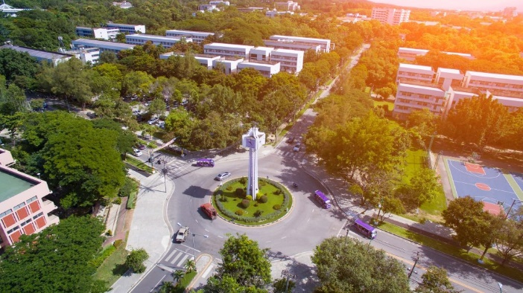
Figure 1 Caption

The abstract should be submitted in PDF format through the T&T IAC website. The deadline for abstract submission is April 22th, 2024.

Acknowledgements
This work was supported by the Theory & Technique International Aerosol Conference (T&T IAC) 2024.

References
Friedlander, S. K. (1977) Smoke, Dust and Haze: Fundamentals of Aerosol Behavior, Wiley, NewYork.
Kasper, G., Schollmeier, S., Meyer, J. and Hoferer, J. (2009) J. Aerosol Sci., 40, 993-1009.
Lee, K. W. and Chen, H. (1984) Aerosol Sci. Tech., 3, 327-334.

